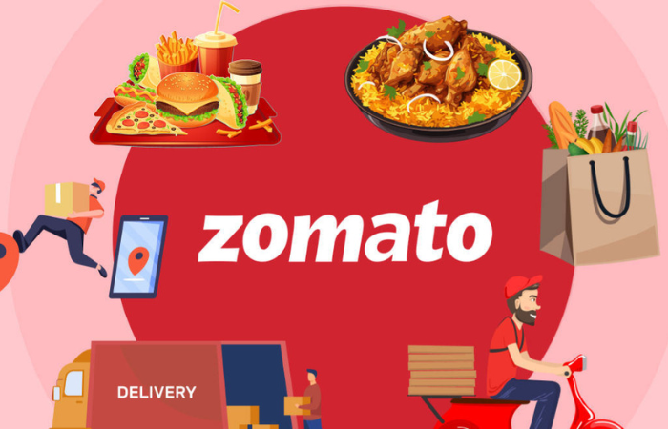

Spreadsheet Project:

Zomato Restaurants Expansion

BY :- Mayank Sinha
Date :- 31/12/2025

Problem Statement. 
You are hired as a consultant data analyst by Zomato where the team is looking for expansion and opening more restaurants. Your task is to develop strategies/suggestions for opening newer restaurants.

Contents
- Data Pre-Processing and Data Cleaning.
- Objective Questions.
- Subjective Questions.

Data Pre-Processing and Data Cleaning.
- Removed duplicates from whole table of raw data provided.
- Handled missing values in data.
- Data Types of Column is properly checked.
- Removed unwanted columns.
- A new column is added with name ‘Customised Price’ for each restaurant with currency symbols.
- Year is extracted in ‘Year’ column from ‘Datekey_Opening’ column for yearly analysis.
- Converted ‘Average Cost for Two’ in to Indian National Rupee (INR) in new column ‘Average Cost for Two in INR’ for proper analysis.

Objective Questions. 

- What is the total no. of tables present in the data?
Answer:- There are two tables present in data provided
- Raw Data of Zomato.
- Country Description.
Image is provided below:

- What is the total no. of attributes present in the data?
Answer:- There are 20 attributes (Columns) Present in the data provided.
- How many categorical columns are there in the data?
Answer:- There are 10 categorical columns in the raw data found using COUNTIF function ‘=COUNTA(UNIQUE(range))’ on each column individually.
Serial no. | Column Name
1 | City
2 | Restaurant Name
3 | Country
4 | Cuisines
5 | Has online delivery
6 | Switch to order menu
7 | Is delivering now
8 | locality
9 | currency
10 | Has table booking

- The data consists of some inconsistent and missing values so ensure that the data used for further analysis is cleaned.
Answer:- Methods used for data inconsistency and missing values are :-
- To Find out missing data I have used ‘Filter Function’.
- Applied Filter on Each Columns and searched for ‘Blank’
- I found missing values in Column ‘Cuisines’
Since blank values are found in cuisines and all missing values are from Country ‘United states of America’ and after watching cuisines value of this country I found ‘Mexican’ Cuisine is more repetitive so I have used function,
=IF(I2="","Mexican",I2)
to fill blank values.
- To make data more consistent I extracted “year” from date of opening provided for proper analysis. Formulae used to extract year mentioned below:
=YEAR(X2)
- To ensure No Duplicates values are there I removed all duplicates by using remove duplicate feature.
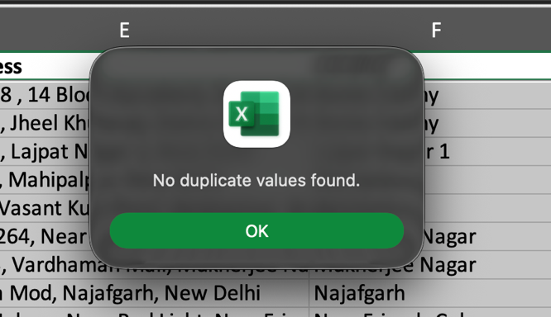
- Hidden Unwanted Columns and removed the columns I don’t need which are Column E and Column G.
- Currency change to INR :
- This data contained restaurants from multiple countries using different currencies. To allow comparative cost analysis, all cost values converted into INR.
- I’ve converted the 'Average Cost for Two' from various countries into a common currency Indian Rupee (INR) to enable consistent comparison in charts and data analysis.
- To support this, I added two helper columns: one for the conversion rate to INR ‘Rate to INR’ and another for the calculated cost in INR (Average Cost of Two in INR).
- Additionally, I set up a currency conversion reference table in a separate sheet titled 'Lookup For Currency'.
- Changed the Date Format because in provided data date format is not looking understandable.

- Using the Lookup functions, fill up the countries in the original data using the country code.
Answer:- For Countries wise analysis we need ‘country’ in our raw data. So created new column named country in D Column and filled column by using VLOOKUP with country code provided in raw data worksheet and country provided along with country code in another worksheet named ‘Country Description’ and formulae used are:
=VLOOKUP(C2,'country description'!A:B,2,0)
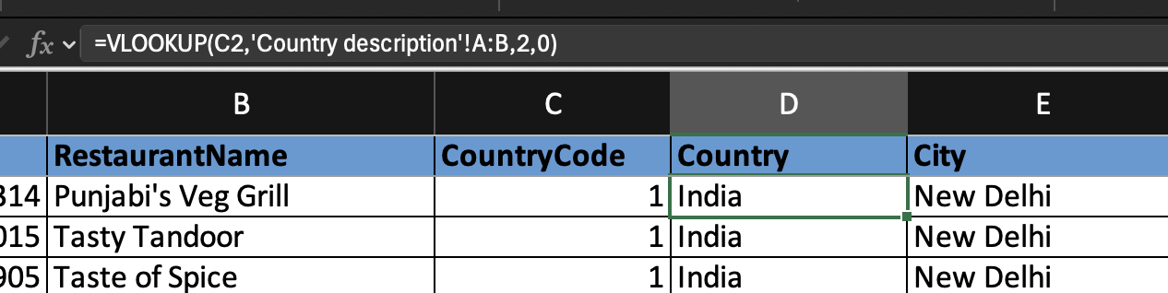

- Create a table to represent the number of restaurants opened in each country.
Answer:-

- To find number of restaurants opened in each country I have created pivot table in worksheet named ‘Objective Questions’ in Excel Sheet.

- By taking countries in row and restaurantID in Values for count to summarize the number of restaurants opened in each country along with pivot graph that is shown below:

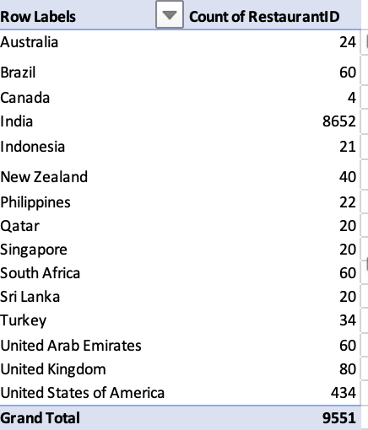
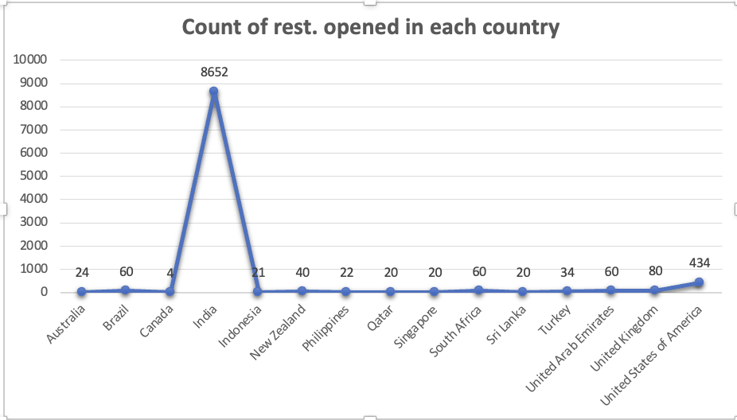
- Visualisation Technique : ‘Line Chart’
Image From ‘Objective Questions’ Worksheet in Excel Sheet.
- Also, the management wants to look at the number of restaurants opened each year, so provide them with something here.
Answer:-
- I created pivot table again in worksheet named ‘Objective Questions’ in in Excel Sheet.
- Taken years in rows and restaurantID in values for count of restaurants on yearly basis to see the number of restaurants opened each year which is shown below:
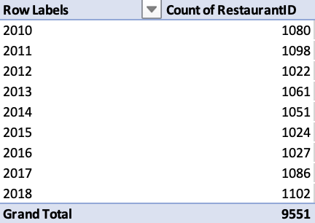
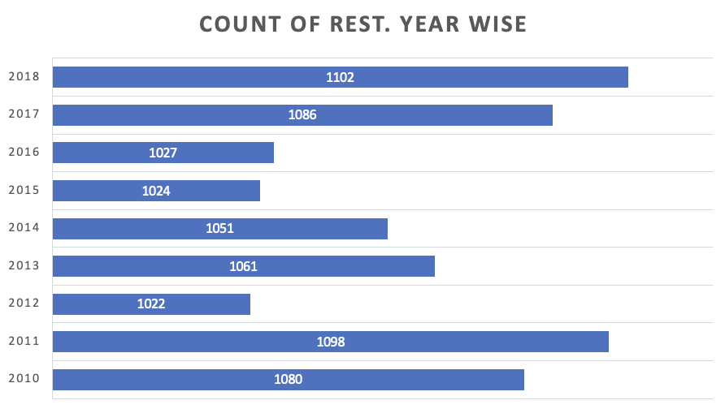
- Visualisation Technique – ‘Column Chart’
Image From ‘Objective Questions’ Worksheet in Excel Sheet.

- What is the total number of restaurants in India in the price range of 4?
Answer:- Total number of restaurants in India in the price range 4 is found out in worksheet named ‘Objective Questions’ in Excel Sheet by using COUNTIFS Functions in raw data provided.
Formulae Used for evaluation are :
=COUNTIFS('Raw Data'!D:D,"India",'Raw Data'!Q:Q,4)
Total number of restaurants in India above price range 4 is shown below:

Image From ‘Objective Questions’ Worksheet in Excel Sheet

- What is the average number of voters for the restaurants in each country according to the data.
Answer:- Analysed the average voter count for each country with Pivot Table in worksheet named ‘Objective Question’ in Excel Sheet which is shown below :
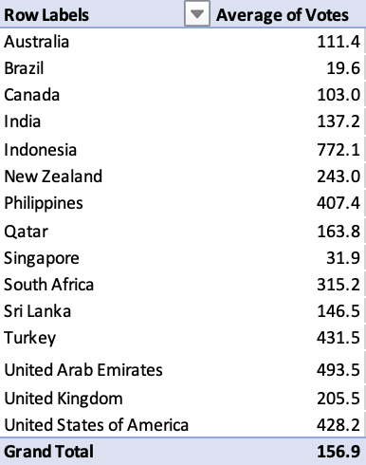
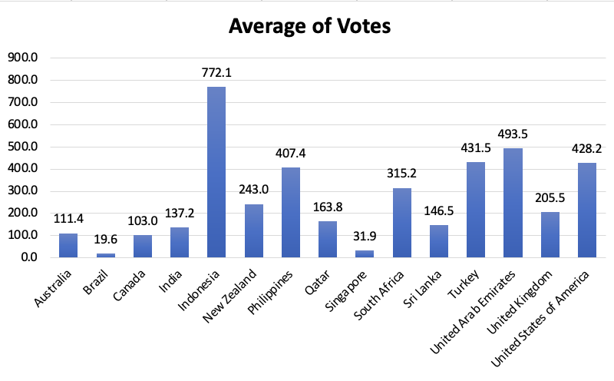
- Visualisation Technique : ‘Column Chart’
Image From ‘Objective Questions’ Worksheet in Excel Sheet

- Calculate the average rating for all the restaurants that have price range < 4 and provide online delivery. Use only the “IF” function, Logical Operators, and Aggregation functions to solve this problem. [Note: Don’t use Conditional aggregation in this question.]
Answer:- In this question we have to avoid conditional aggregation so I used IF function with logical operators to fulfil the criteria based evaluation needed in question. AVERAGE function is used to calculate average ratings for the both criteria given above and formulae used are mentioned below:
=AVERAGE(IF(('Raw Data'!Q:Q<4)*('Raw Data'!N:N="Yes"),'Raw Data'!U:U))
Image From ‘Objective Questions’ Worksheet in Excel Sheet
- Using Conditional formatting highlight the rows of restaurants that are located in the countries or cities that you’ve suggested to the management for opening new restaurants.
Answer:- Two factors is being considered for suggesting countries or cities for opening new restaurants are:
a) Count of restaurants in each country .
b) Average rating of restaurants in each country
- Accordance with that ‘Australia, Canada, Sri Lanka, Singapore and Brazil’ is countries where opening new restaurants are suggested.
- Because the restaurants appeared multiple times indicate higher popularity and the restaurant has an rating above 3.5 or above showing strong customer feedback.
To check this two new column is created as ‘Count of restaurants’ and ‘Average of Ratings’ in worksheet named ‘CF_SuggestedRestaurants’
Formula used are:
=COUNTIFS(B:B,B2)

And =AVERAGEIFS(U:U,B:B,B2)
Conditional Formatting Rule Used:
=AND(OR(D2="Australia", D2="Canada", D2="Singapore", D2="Brazil", D2="Sri Lanka"), Z2 >1 , AA2 >=3.5)

- Create a new customised price column that consists of the abbreviation/symbol of the currency along with the Average_cost_for_two value. [Use string operations to do this task]
Answer:-
- Created a table in ‘LOOKUP Currency’ worksheet which contains Currency and Symbol table.
- Also, I have created ‘currency symbol’ column in my raw data to retrieve symbols using VLOOKUP from table which is in lookup currency worksheet.
- Then ‘customised price’ column created and price is assigned with symbol using CONCAT function created as question asked.
Formula used are:
=VLOOKUP('Raw Data'!K3,'LOOKUP Currency'!$A$1:$B$13,2,0)
And =CONCAT(U2," ",S2)
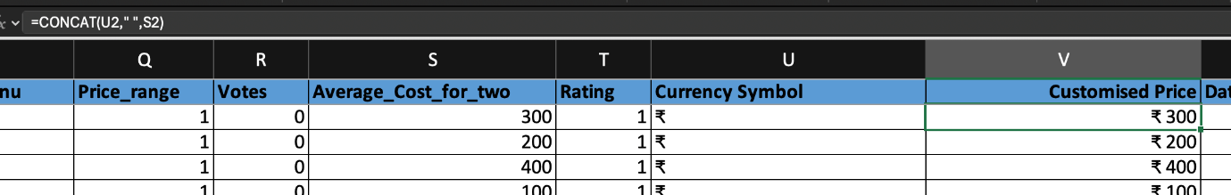

- How can you create an array formula in Excel or Google Sheets to count the number of restaurants listed that do not offer online delivery, are in the lowest price range, and have an average cost for two people less than or equal to 250 Indian Rupees?
Answer:- We have three conditions given
- ‘No’ online delivery
- ‘Lowest’ price range (price range = 1)
- Average cost for two ‘≤ 250 INR’
for counting number of restaurants depending on these using Array Formula.
Now We need average for of two in INR for accurate and effortless calculation so for this created new column already as ‘Average Cost of Two in INR’ to fulfil the ‘Average cost for two ≤ 250 INR’ criteria.
Result is generated in Objective Questions Worksheet as shown below:

Using Array Formula (Ctrl + Shift + Enter.)

Formula :
=SUM(('Raw Data'!N2:N9552="No")*('Raw Data'!Q2:Q9552=MIN('Raw Data'!Q2:Q9552))*('Raw Data'!Y2:Y9552<=250))
Note:- The array formula which I have used works through utilizing multiplication as the primary filtering mechanism. Instead of counting based on criteria, we generate a product for every row:

- A product of 1 is assigned when the row meets all criteria, i.e. 1 * 1 * 1 = 1

- A product of 0 is assigned when it doesn't meets all criteria i.e. 1 * 0 * 1 = 0.
Summing this array of products is therefore mathematically equivalent to a conditional count.

Subjective Questions.



1. Suggest a few countries where the team can open newer restaurants with lesser competition. Which visualization/technique will you use here to justify the suggestions?
Answer:- Considered two parameters to evaluate this :
- Count of Restaurant IDs.
- Average rating of restaurants in each country.
Approach:
- Pivot Table Analysis: Used pivot tables in the ‘Subjective Questions’ worksheet to compare and analyse data.
- Country-wise Analysis: Rows represent countries, with values showing average rating and the count of restaurants.
- Market Insights: High restaurant counts indicate high demand and competition, while low counts suggest market gaps and growth potential. Average ratings reflect customer satisfaction levels.

Analysis:
- My recommendation is to target markets characterized by low restaurant count and subpar average ratings.
- These conditions specifically a count below 30 and an average rating under 3.5 create a strategic gap.
- We can exploit this gap by performing a detailed market study to isolate and resolve the causes of low customer satisfaction.
Insights:
- Market Opportunity:
Low average ratings and restaurant count indicate a quality-based gap, suggesting an opportunity to excel by offering superior quality, consistency, and service.
- Competitive Advantage:
Entering a market with low restaurant count provides a first-mover advantage, enabling brand recognition and prime location acquisition.
- Cultural Sensitivity:
Adapting to local tastes and socioeconomic realities is crucial for success, as existing restaurants may be failing to meet customer expectations.
Reference:
- Pivot table analysis targets countries with <30 restaurant IDs and <3.5 average ratings.
Suggested countries are mentioned below:
      - Sri Lanka.
      - Australia.
      - Canada.
      - Singapore.
      - Brazil.

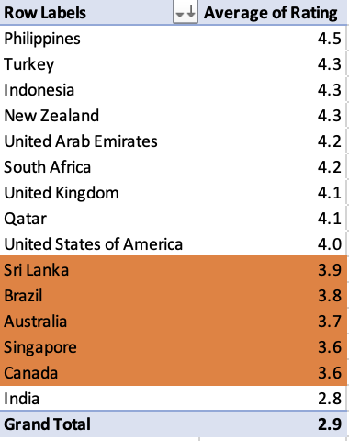
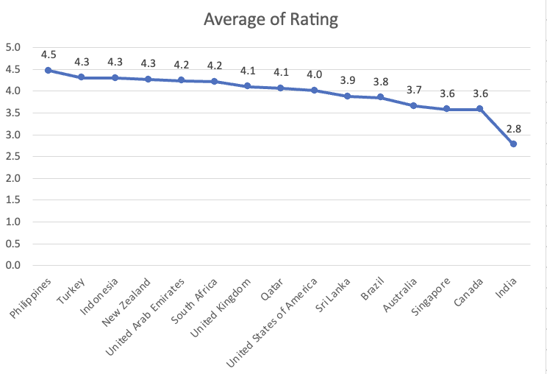

- Visualisation Technique : ‘Line Chart’
Image From ‘Subjective Question 1’ Worksheet in Excel Sheet

Recommendations:
1. Market Research: Conduct an in-depth qualitative study in the top 3 suggested countries to identify the root cause of low average ratings.
2. Concept Development: Design a restaurant concept that directly addresses the identified customer pain points.
3. Small Scale Entry: Start with a smaller-scale pilot in the capital city of the top country to minimise initial capital risk and allow for real-time adjustments.

2. Come up with the names of States and cities in the suggested countries suitable for opening restaurants.
Answer:-
Analysis and Approach :
- To Come up with the cities suggestion of country suggested.
- I have taken the same approach by making pivot table and focused on average of rating in each cities and this time taken ‘has online delivery’ in value field also to check whether online facility is available or not.

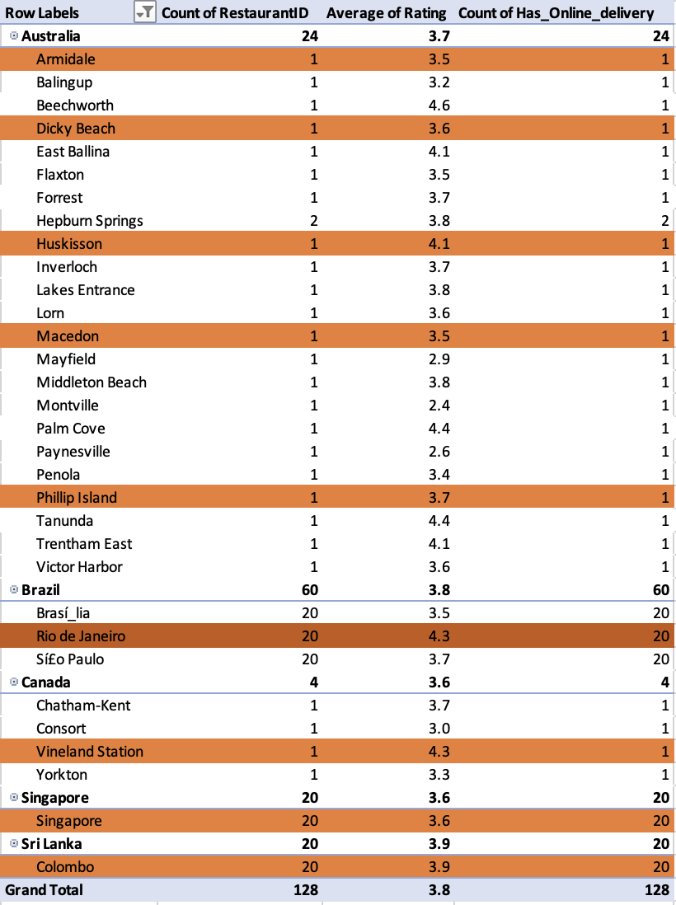

Image From ‘Subjective Question 1’ Worksheet in Excel Sheet
Suggested Cities:
According to analysis suggested cities are: a) Armidale, Dicky, Beach, Huskisson, Macedon, Philip Island from Australia.
b) Vineland station from Canada.
c) Singapore from Singapore.
d) Colombo from Sri Lanka.
e) Rio de Janeiro from Brazil.

Recommendations:
1. Australia: Focus on Quality in Regional & Tourist Hubs.
Recommendations:-
For Coastal/Tourist (Dicky Beach, Huskisson, Phillip Island): High-Quality, Casual Dining with a strong, local concept. Target visitors and higher-income locals seeking a better-than-average option.
Regional/Inland (Armidale, Macedon): All-Day/Café Concept that transitions to a quality dinner offering. Focus on fast service for the local workforce/students.
2. Canada (Vineland Station, Ontario): Niche in Agri-Tourism.
- Vineland Station is in the heart of the Niagara wine region, a destination for food and wine lovers.

Recommendations:-
Farm-to-Table/Artisanal Niche with a strong online presence. Position the restaurant as a higher-rated alternative to existing options.

3. Singapore: Cloud Kitchen for Cost Efficiency.
- Singapore is a highly competitive, expensive market with a mature and highly utilized food delivery infrastructure.

Recommendations:-
Cloud Kitchen/Delivery-Only Model for a niche cuisine (e.g., highly specific regional Asian, healthy/diet-focused meals). This avoids high rental and labour costs.

4. Sri Lanka (Colombo): Capture the Emerging Middle-Class.

- Colombo's market is growing, with a significant demand for quality international and fusion concepts, especially among the young, urban population.

Recommendations:-
Full-Service, Mid-to-High-End International Concept with seamless digital integration. Address the "low average rating" by offering a superior overall customer experience.

5. Brazil (Rio de Janeiro): Prioritize Digital Experience
- The Brazilian food delivery market, dominated by online delivery platforms. Low average ratings indicate a massive failure of existing restaurants to maintain quality across digital orders.
Recommendations:-
High-Volume, Optimized QSR/Casual Concept designed specifically for delivery. This should be a ghost kitchen or a small-footprint outlet in a high-density zone.

3. According to the countries you suggested, what is the current quality regarding ratings for restaurants that are open there?

Answer:-
Approach :
- To answer this I have taken pivot table approach again.
- By taking average rating as main factor.
- Taken Country in rows and Average of Rating in values as average value excel worksheet named ‘Subjective Questions 2’.
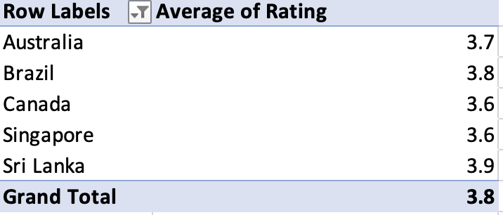
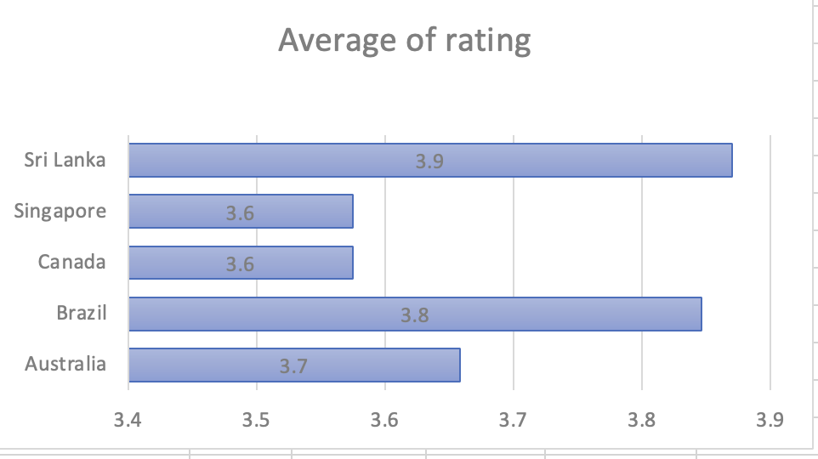
- Visualisation Technique : ‘Horizontal Bar Chart’
Image From ‘Subjective Question 2’ Worksheet in Excel Sheet
Analysis and Recommendations : Putting Countries in rows and Average rating In value as average few points I observed that are as follows:
- Every Country that are taken in consideration have rating between 3.6 to 3.9.

- Sri Lanka have highest average rating of 3.9 and Canada and Singapore have lowest rating of 3.6.
- Despite the differences in ratings, all these countries showing positive trends having rating between 3.6 to 3.9 which shows generally good restaurant quality.

- Sri Lanka, holding the highest rating, appears to have a market characterized by well-established, potentially upscale dining options or particularly demanding consumer standards.

- In contrast, while Singapore registers the lowest rating at , this score remains quite respectable on a global scale.

- This suggests that while Singaporean dining is generally high-quality, there may be inconsistencies in areas like service or food execution that slightly temper customer satisfaction.

- The minimal overall variation in scores indicates that all these countries possess a fundamentally robust restaurant sector, even if specific markets offer slight margins for enhancement.

4. Also, what is the current expenditure on food in the suggested countries, so we can keep our financial expenditure in control?
Answer:- Approach :
- For Current expenditure calculation to keep the financial control I have used pivot table
- Taken country in rows and avg cost for two in INR and count of restaurants in values in ‘Subjective Question 2’ worksheet.
Analysis of expenditure being calculated :
For clear view I have made a separate table for suggested countries expenditure which contains values of estimated expenditure equals to avg cost of two multiplied by count of restaurants in the country.
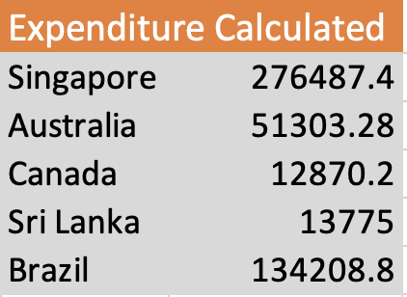
Formula to extract expenditure for each country are :
=GETPIVOTDATA("Average of Avg cost of two INR",$L$4,"Country","Singapore")*GETPIVOTDATA("Count of RestaurantID",$L$4,"Country","Singapore")
Applied Same to for all countries.
Used ‘Pie Chart’ for clear view for expenditure comparisons between suggested countries which is shown below:

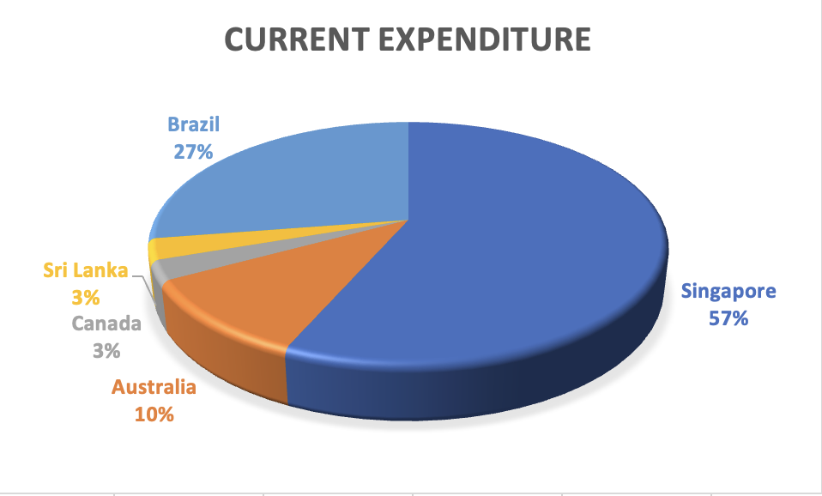
Observation :
- Singapore food spending with ₹2.6 lakh , accounting for the vast majority of total expenditure.
- While countries like Sri Lanka, Brazil, and Canada contribute marginally, highlighting a significant spending gap across countries.
Key Insights:

1. Extreme Spending Disparity.
- Singapore accounts for most of the overall food budget due to its high average dining costs, larger number of restaurant suggestions, and expensive market conditions.

2. Financial Pressure Point.
- Decisions in Singapore largely determine total expenditure, while changes in Sri Lanka, Brazil, or Canada have little effect, making them low financial risk.

3. Value/Market Indication.
- Sri Lanka, Brazil, and Canada provide cost-effective dining options and allow more restaurant reviews per rupee spent, resulting in better ROI.

For Visualisation purpose I am mentioning pivot table and combo chart of count of restaurants vs average cost of two in INR .
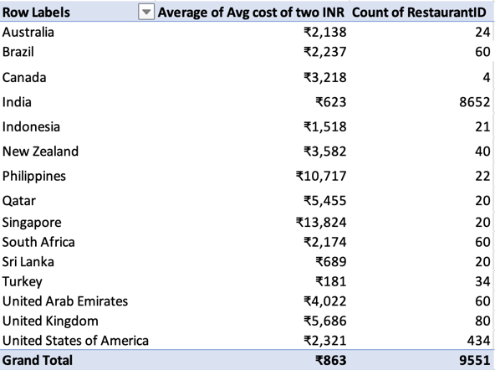
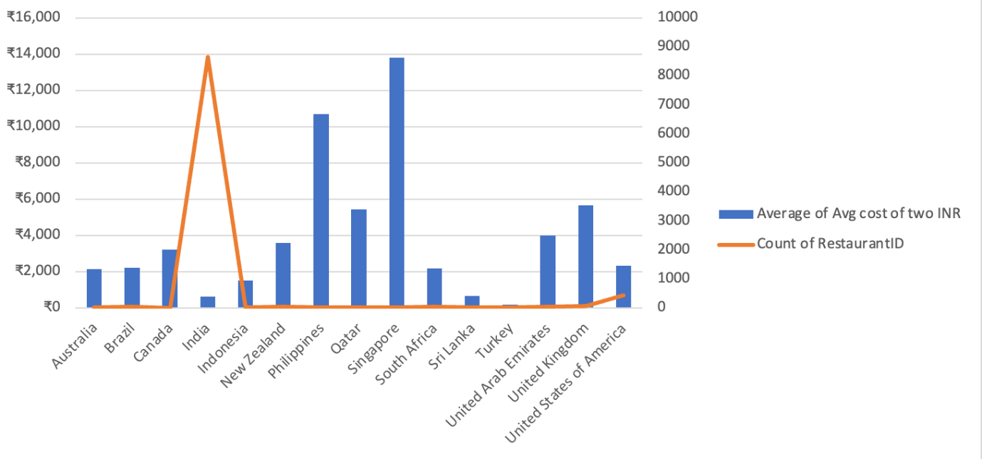

Visualisation technique : ‘Combo Chart of Bar and Line Chart’
Image From ‘Subjective Question 2’ Worksheet in Excel Sheet.

Recommendations:
To effectively manage the overall financial expenditure, particularly keeping the Singapore figure in check, the following recommendations are crucial:

1. Budget Re-Allocation and Control.
Singapore Focus: Cut the two main Singapore cost drivers—the average meal price and number of reviewed restaurants. Allocate most of the food budget there but impose a strict spending cap. Budgets for Sri Lanka, Brazil, and Canada can be minimal.

2. Strategic Dining Choices in Singapore.
Choose Cheaper Options: Prioritise low-cost places like hawker centres and local eateries to lower average costs. Limit the number of expensive restaurant reviews to those essential for the project.

3. Shifting Project Focus.
Increase Low-Cost Reviews: Boost review numbers in Sri Lanka, Brazil, and Canada to maximise content and keep costs down, offsetting Singapore's higher expenses.

5. Come up with the names of restaurants from the recommended states that are our biggest competitors and also those that are rated in the lower brackets, i.e. 1-2 or 2-3.

Answer:-
Approach :
- Used Pivot table concept to analyse this question.
- By taking countries and restaurants in rows and average of ratings in values with average of votes in excel worksheet named ‘Competitors and Low Rated Rest.’
Based on this I evaluated competitors in pivot table which is shown below:
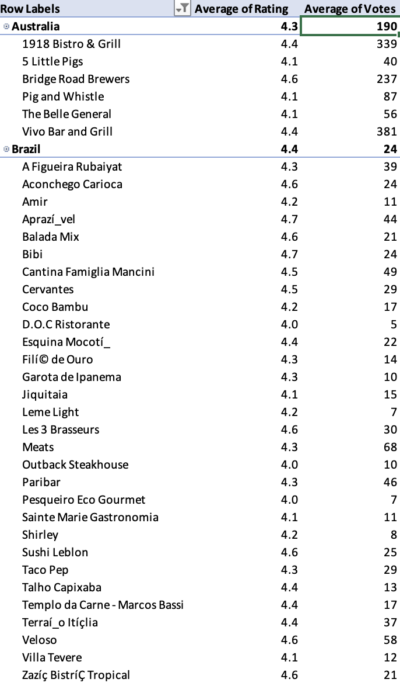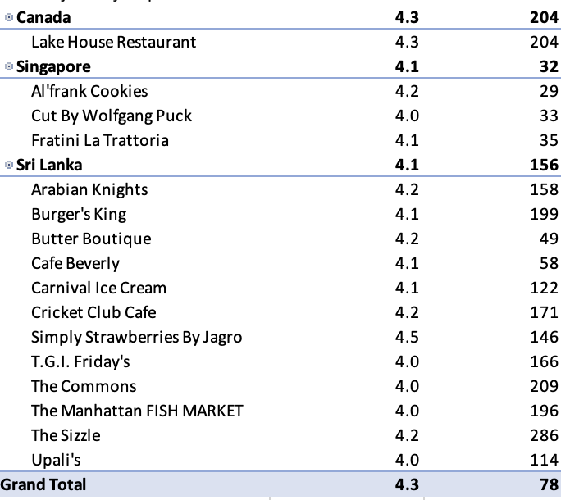
Image From ‘Competitors and Low Rated Rest’ Worksheet in Excel Sheet

Insights about Competitors available
The analysis highlights several high-performing restaurants in Canada, Sri Lanka, and Australia, each achieving ratings above 4 and attracting considerable customer engagement, as evidenced by vote counts ranging from 150 to over 380.

Key Competitors Identified
- Australia:
- 1918 Bistro & Grill, Bridge Road Brewers, and Vivo Bar and Grill have established themselves as leading competitors in the Australian market. These venues exhibit consistently high customer satisfaction and have garnered significant positive feedback, setting a benchmark for quality and service.
- Canada:
- Lake House Restaurants stands out as a top competitor, reflecting strong customer approval and a robust vote count, which underlines its popularity and reputation for excellence within its region.
- Sri Lanka:
- The Commons and The Sizzle are prominent competitors, demonstrating both high ratings and substantial customer feedback. Their popularity positions them as leading benchmarks for service and quality in Sri Lanka.

- Each of these restaurants exemplifies strong customer satisfaction.
- Also have marketplace popularity, making them important benchmarks for assessing quality and service standards within their respective regions.

Insights about restaurants rated in lower bracket
According to pivot table shown I summarised low bracket rated restaurants
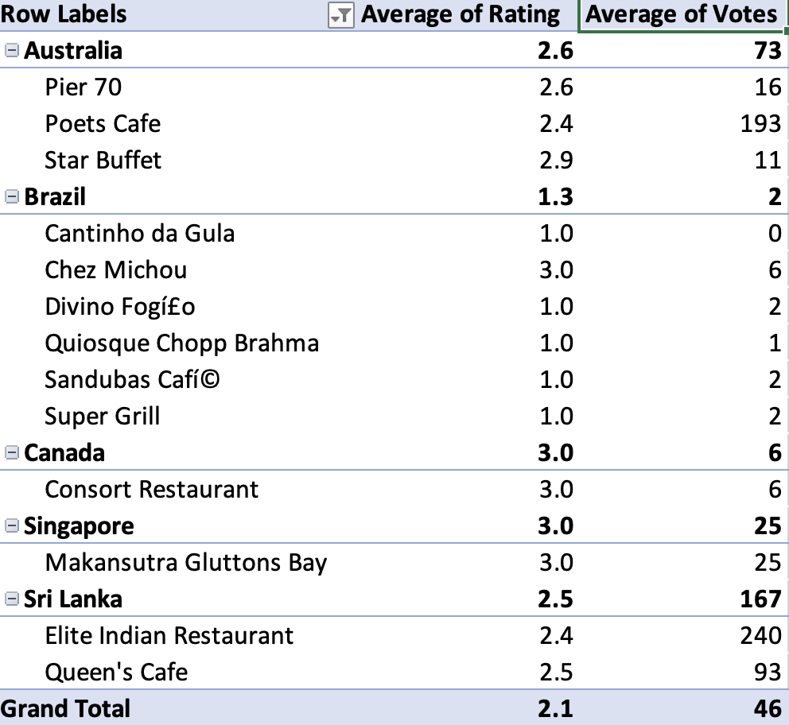
Image From ‘Competitors and Low Rated Rest’ Worksheet in Excel Sheet

Insights on Low-Rated Restaurants

Overall Quality Concerns
An analysis of the listed restaurants reveals a general problem with customer satisfaction. The majority of these establishments fall within a low satisfaction range, with ratings between 1.0 and 3.0. The average rating is approximately 2, indicating a significant gap in meeting customer expectations.

Market-Specific Observations
- Brazil Faces Major Issues:
- Five out of six venues in Brazil have an average score of 1.0, reflecting a severe lack of quality and reliability.
- This market appears to require significant intervention, including thorough reviews and potential operational changes.
- Mid-Low Ratings in Australia and Sri Lanka:
- Australian restaurants show ratings between 2.6 and 2.9, along with a modest number of votes, suggesting inconsistent service quality.
- Similarly, Sri Lankan establishments display low ratings, even with high customer engagement. For instance, the Elite Indian Restaurant is frequently visited (with 240 votes) but still receives low satisfaction scores.

High Engagement, Low Satisfaction
- Both Poets Cafe (Australia) and Elite Indian Restaurant (Sri Lanka) attract a significant number of votes but continue to record low ratings (2.4–2.6). This persistent pattern indicates ongoing customer dissatisfaction despite high visibility and patronage.

Recommendations on Low Rated Restaurants
- Immediate Quality Review in Brazil:
- Given the prevalence of 1.0-rated restaurants, it is advisable for Zomato to conduct partner reviews, remove consistently poor performers, and onboard more reliable replacements.
- Support for High-Engagement, Low-Rated Restaurants:
- Outlets such as Poets Cafe and Elite Indian Restaurant, which experience substantial customer interaction but deliver low satisfaction, should be prioritised for interventions like staff training, menu updates, and comprehensive service reviews.
- Strategic Focus on Mid-Tier Markets:
- Sri Lanka and Australia could benefit from curated onboarding processes for promising restaurants and by promoting venues that have ratings above 4.0, even if these are not currently highlighted.

Ongoing Monitoring and Reputation Management
- It is recommended that restaurants with ratings between 1 and 3 be closely tracked using automated alerts. Negative reviews from these establishments have the potential to harm Zomato's global brand reputation and should be addressed proactively.

6. Which cuisines should we focus on in the newer restaurants to get better feedback? Does the choice of cuisines affect the restaurant ratings?
Answer:-
Approach:
- In order to analyse the factors influencing cuisine preferences at emerging restaurants for improved feedback, I employed a chart visualisation technique.
- Chart Used:- Line Chart using Pivot Table.
- In Pivot Table I have taken country and cuisine in row and average of rating in value in the excel worksheet named ‘Cuisine Analysis’.
Analysis and Insights:
- Visualisation Technique : ‘Line Chart’

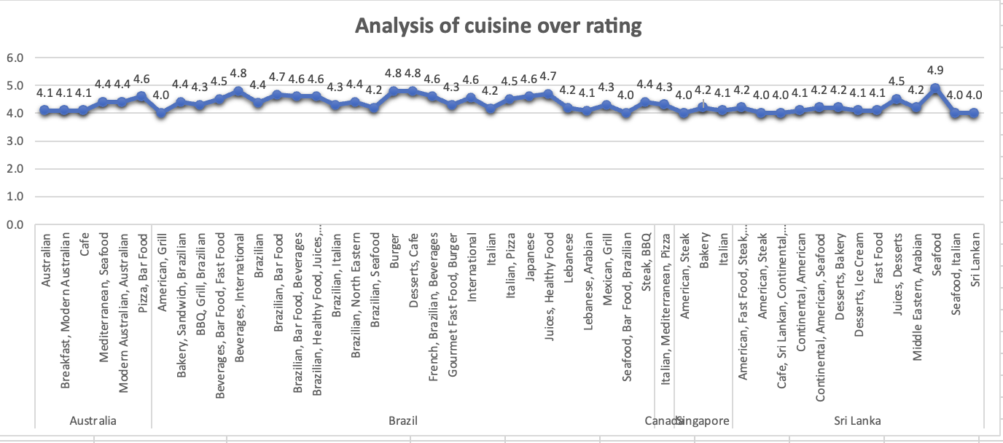
Image From ‘Cuisine analysis’ Worksheet in Excel Sheet

- Upon reviewing the chart, it is evident that the predominant dining preferences among
- Australians include Pizza, Bar food, Mediterranean cuisine, and Modern Australian Breakfast.
- Canadian respondents show a marked preference for Japanese and Sushi, Chinese, and Italian cuisines.
- In Singapore, Bakery items, American Steak, and Continental dishes are notably popular.
- Brazil have popularity in Brazilian foods mostly.
- Sri Lankan individuals demonstrate a strong inclination towards Seafood,
Juices, and Desserts.

According to our data top 10 cuisine is also evaluated for better insight below:
- Visual Technique used: ‘Column Chart’
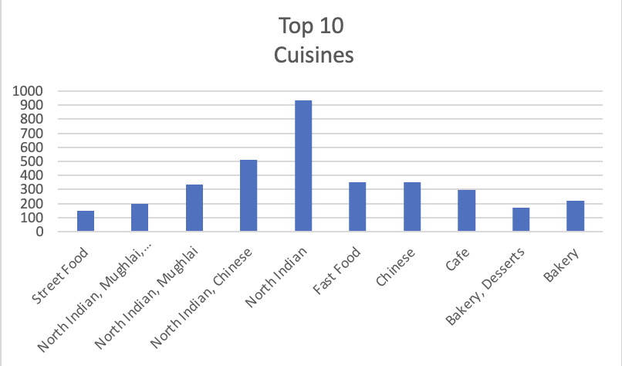
Image From ‘Cuisine analysis’ Worksheet in Excel Sheet

Recommendations:
• Restaurant Rating and Cuisine Type: Restaurant ratings are strongly correlated with cuisine types.
• Menu Strategy for New Restaurants: Prioritise popular local dishes to meet customer expectations and gain positive reviews.
• Emerging Food Trends: Introducing modern options like plant-based or farm-to-table dishes can attract a wider customer base.

7. According to our current data, should we go for online delivery and table booking? Does that affect the customer’s ratings?

Answer:- Approach :
- I have checked the facility of online booking and table booking are available or not in suggested countries.
- To evaluate this I created a separate table in ‘Online Booking’ Analysis worksheet.
- Taken the country column and the Has online delivery column and the Has table booking column into consideration.
- I have found none of the selected countries(suggested for expansion have online delivery and online booking.
Table is shown below:
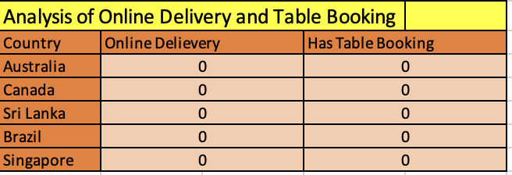
Image From ‘Online booking analysis’ Worksheet in Excel Sheet

Applied formulas:
=COUNTIFS('Raw Data'!N:N,"Yes",'Raw Data'!D:D,"Australia")
(for Australia - Online Delivery)
=COUNTIFS('Raw Data'!M:M,"Yes",'Raw Data'!D:D,"Australia")
(for Australia - Table Booking)
Similar formulas are used for both criteria in the other four countries.

Analysis :
- Visualisation technique used: ‘Pie Chart’
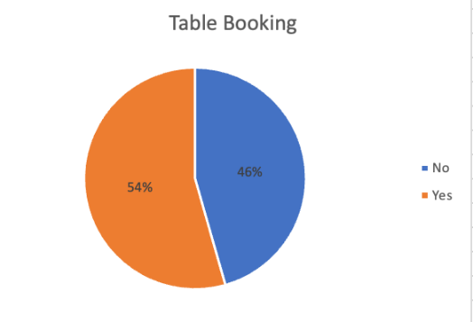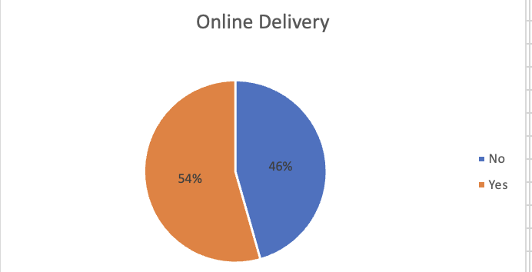
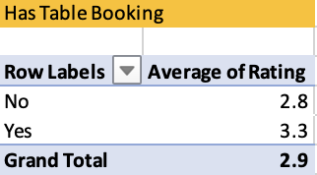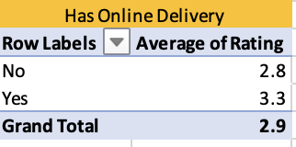
Image From ‘Online booking analysis’ Worksheet in Excel Sheet

- I used pivot tables to compare the average ratings of online delivery and booking services, evaluating their impact based on facility availability.
- Taken ‘Has Table Booking’ and ‘Has Online delivery’ in rows respectively and average of rating in value.
- Both average rating calculated separately in two pivot tables for clear picture.

Insights:
- Countries that provide online booking and delivery services tend to see an increase in both ratings and votes. These countries not only have higher average ratings, but also receive more votes overall.
- Based on all this data, it's clear that online services are having a positive impact on the rating.
Suggestions:
  - Implementing online delivery and table booking services in these countries could provide a competitive advantage.
  - Local restaurants in these countries lack such services.
  - It is important to analyse pricing, service availability, and customer willingness to pay more.

- Should the team keep the rate of cuisines higher? Will that affect the feedback? According to our data are the rates of cuisines and ratings, correlated?

Answer:- Approach:
- Set up a pivot table named “Correlation between Cuisine and Rating” in an Excel worksheet.
- Filtered the pivot table for recommended countries.
- Listed cuisine types of these countries as row fields.
- Calculated the average rating and average cost (for two people) in INR for each cuisine type.
- Displayed these averages in the value fields of the pivot table.
- Created a scatter chart to illustrate the relationship between ratings and costs.

Additionally, I used the CORREL function:
=CORREL(M6:M1831,N6:N1831)
This allowed me to determine the correlation between cuisine ratings and average costs for two people in INR shown below:
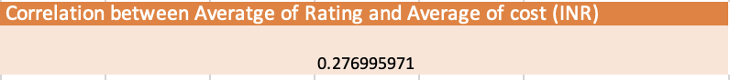
Insights :
- Visualisation technique used: ‘Scatter Plot’

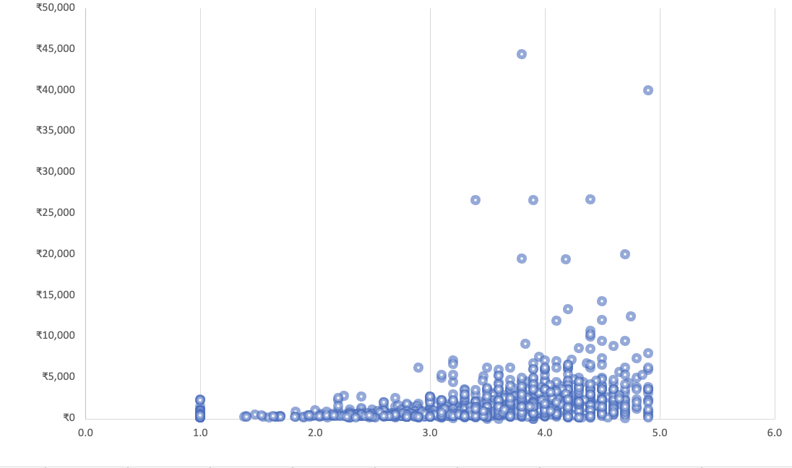
Image From ‘Correlation Cuisine and rating’ Worksheet in Excel Sheet

Relationship Between Cuisine Ratings and Average Cost of two in INR.
- From the analysis of the graph, it is evident that as the rating of cuisines increases, the average cost for two people also rises.
- Cuisines with ratings over 3.5 usually cost more, so if the food gets better reviews, you can expect to pay higher prices.
- To quantify this observation, the correlation coefficient was calculated above The findings indicate a positive relationship between the average rating of a cuisine and the average cost for two people.
Suggestions/Recommendations:
The analysis clearly shows a positive correlation between the cuisine rating and the average cost (for two people). Higher-rated cuisines generally have a higher cost.
- Maintain a Balance of Cost and Quality:
- Strategic Pricing: Since higher ratings correlate with higher costs, the team should consider keeping the rate of high-quality (high-rated) cuisines higher to match customer expectations and cover the associated premium in ingredients, preparation, or ambiance.
- Focus on Value: For mid-range or lower-cost options, the team should strive to offer the best possible quality/value ratio to ensure competitive ratings even at lower price points.
- Use High-Cost Cuisines as a Premium Offering:
- Maximize Profit from Highly Rated Cuisines: The team can use the high-rated, high-cost cuisines (e.g., those rated ) as premium offerings to attract customers willing to pay more for excellent feedback/quality. This will likely affect the feedback positively by delivering a high-end experience that justifies the price.
- Investigate Low-Cost, High-Rating Anomalies:
- Identify Best Practices: Look closely at any cuisines that have a high rating (e.g., ) but a lower-than-average cost. These anomalies represent excellent value for money. The team should analyse these options to replicate their success (e.g., efficient sourcing, unique preparation) across other menu items.

- Transparency in Pricing:
- Manage Expectations: Be transparent about the pricing structure. When increasing the price of a cuisine, ensure the quality, presentation, or portion size is noticeably improved to justify the higher rate and maintain good feedback. The positive correlation suggests customers are generally willing to pay more for better food.

- What is the distribution of the number of restaurants of different price ranges in all the countries?
Answer:- Approach:
- I have created a pivot table for analysis above question by taking countries in rows and price ranges in column.
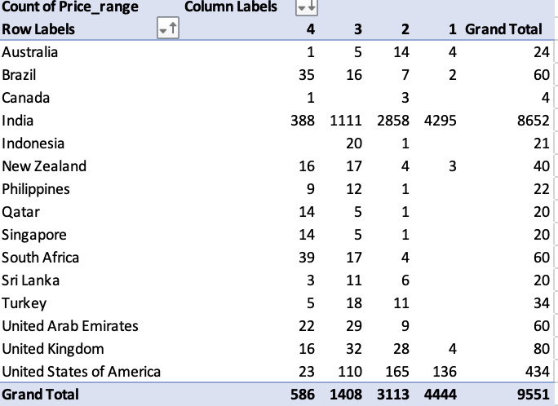
Insights:

Distribution of Restaurants by Price Range Across Countries
- India clearly leads the dataset as the largest market, with more than 85% of its restaurants falling into the low to medium price categories (ranges 1 and 2). This shows that affordable dining options are especially popular among Indian consumers.
- Meanwhile, the USA, UAE, and South Africa have a more even spread across price ranges, but their restaurants tend to cluster around ranges 2 and 3. This suggests that diners in these countries prefer a mix of budget and mid-tier options.
- In Australia, the UK, Singapore, and Canada, mid-to-premium restaurants (ranges from 3-4) are more common than budget ones. This likely reflects a customer base with higher spending power or a greater demand for upscale dining experiences.
- Finally, countries like Qatar, Turkey, and Indonesia have only a handful of restaurants represented in the dataset. Most of these are in the higher price brackets, which could indicate untapped opportunities or small but specialized markets.
- Visualisation Technique used: ‘3 D column Full Stack Chart’

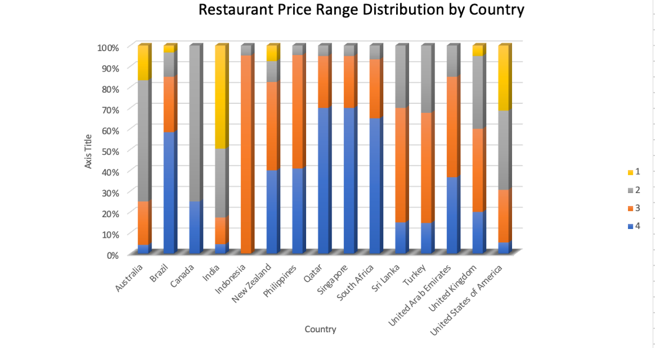
- Visualisation Technique: ‘Combo Chart of Bar and Line Chart’
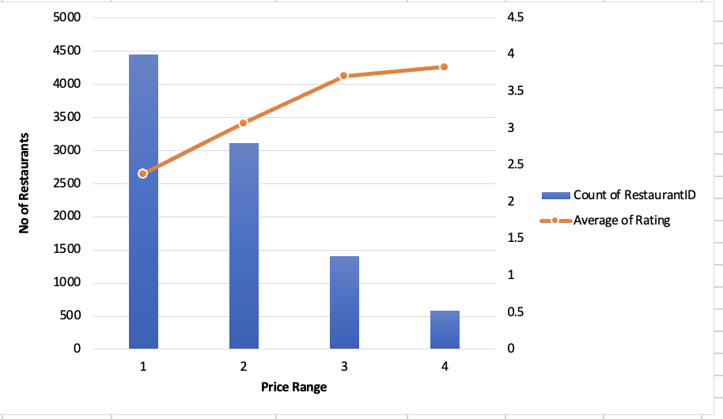
Image From ‘Price range and count of rest.’ Worksheet in Excel Sheet

Suggestions :
- In India and Brazil, Zomato could really connect with budget-friendly restaurants by:
- Launching combos, loyalty programs, simple affordability filters, and price-focused campaigns.
- For people in the USA, UAE, UK, and Australia.
- Highlight premium listings with quality tags and chef’s specials, and offer premium memberships including reservations and exclusive deals.
- And in places where Zomato isn’t as well-known are Indonesia, Qatar, or Sri Lanka
- Start by testing locally, partnering with restaurants, and running pilots to determine effective pricing.

- Explain your approach in brief for suggesting countries/cities in order to open new restaurants, if the objective and subjective questions would have not been given to assist you. [you have to give bullet pointers in order to answer this question]
Answer:-

Approach for Identifying Suggested Countries and Cities for Restaurant Expansion
To determine the most suitable countries and cities for opening new restaurants, a systematic approach was adopted based on key performance indicators and market characteristics:
- Selection of Countries.
- Evaluated countries by examining factors such as the average restaurant rating (specifically considering those with a rating greater than 4).
- Identified countries where the total number of restaurants is currently low, indicating potential market gaps and opportunities for new entrants.
- Considered average vote counts, focusing on countries where restaurants receive a high volume of votes, which suggests active customer engagement and potential demand.
Identification of Suitable Cities:
- Within the shortlisted countries, cities were further assessed for their suitability for expansion.
- Gave preference to cities with a higher average cost for two, which can contribute to better revenue generation for new establishments.
- Selected cities with a lower number of existing restaurants, reducing competitive pressure and increasing chances for successful market entry.
- Ensured that the chosen cities have an above-average restaurant rating (greater than 3.5), indicating positive customer experiences and favourable dining culture.
Cuisine Analysis:
- Analysed popular cuisines within the identified cities to understand local preferences and trends.
- Focused on cuisines that not only have high ratings but also command a higher average cost for two, supporting the objective of enhanced revenue generation.
- Prioritised cuisines already in demand, as their popularity can attract a larger customer base and facilitate quicker market penetration.

